See 618.9 for the sequence of tasks … but first check data create new data in S02:
Current data (starting with ZZ*):
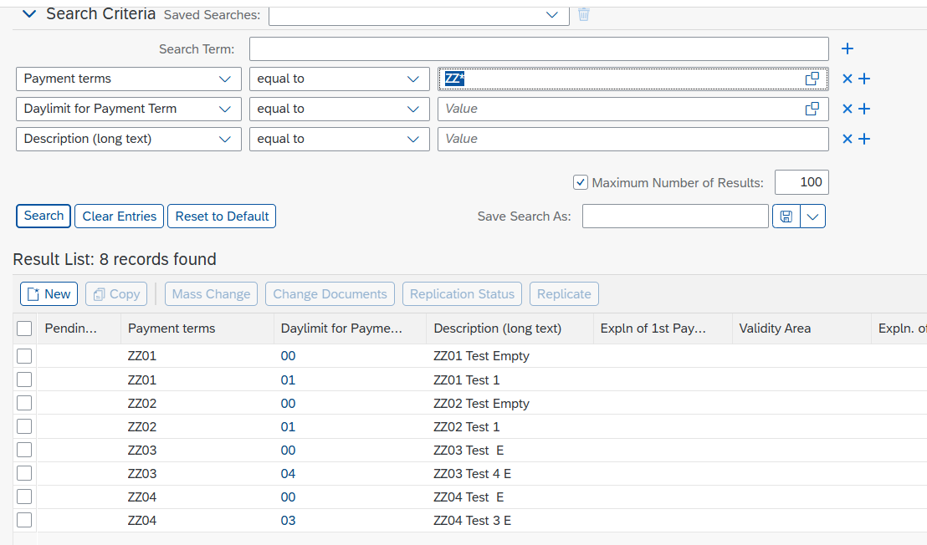

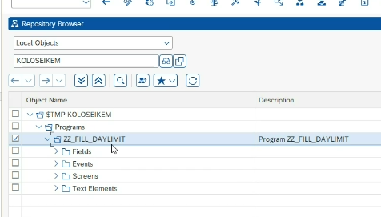

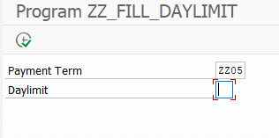

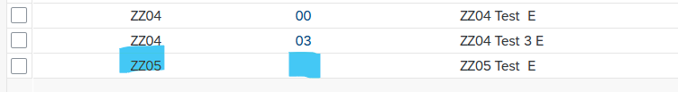

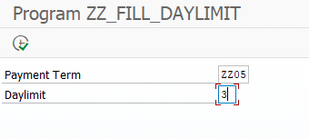

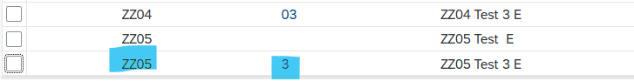

Texts
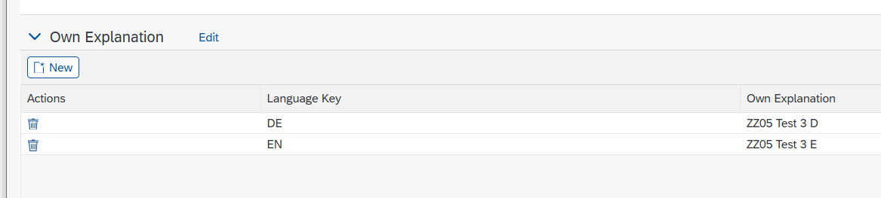

- Creation of a download variant for the daylimit information
- Download of ALL daylimit information

- Creation of a download variant for language-dependent texts of daylimit
- Download of ALL language-dependent texts for all daylimits

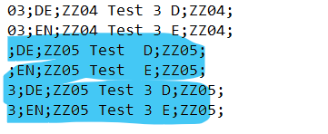

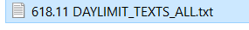

- Creating and uploading corrected daylimit information to create new correct data

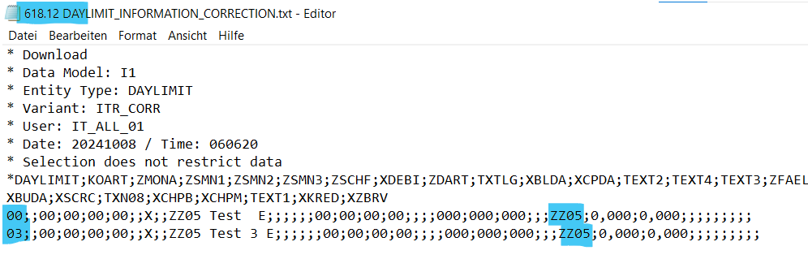

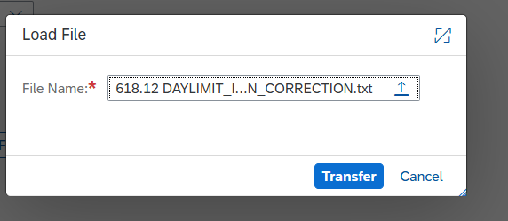

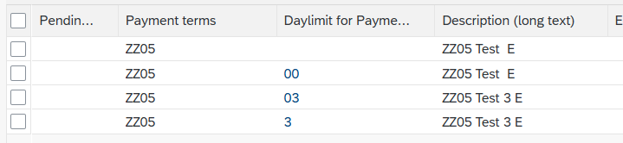

- Re-Download of ALL daylimit information (incl. corrected data)

- Adjustment of downloaded file of daylimit information for re-upload

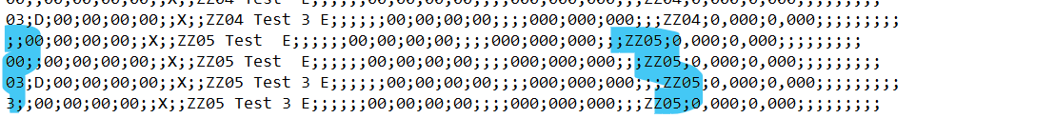

- Upload and Replace daylimit information in the MDG Staging Area

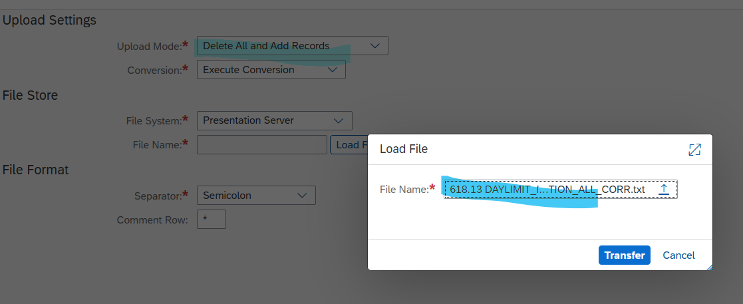

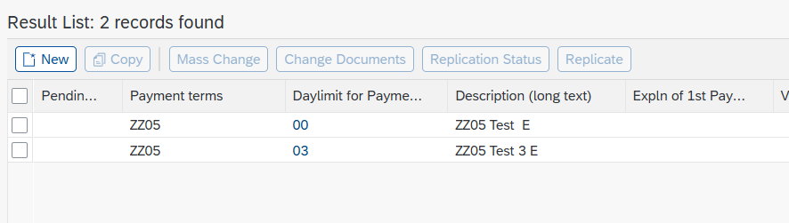

- Adjustment of downloaded file of language-dependent texts of daylimits

